**VIEWING THIS COURSE IN HIGH DEFINITION**  
This course is presented in high definition. If your internet connection is up to it, be sure the 'HD' option is selected while watching videos. If videos look grainy and pixelated, you probably don't have HD selected. When HD is selected, the button turns on, as below (on desktop):

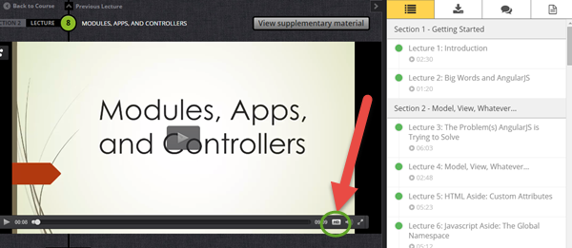

If the HD button is black, that means you don't have it on. Just click it to turn the option on and enjoy this course in HD!

**VIEWING THIS COURSE OFFLINE OR AT DIFFERENT SPEEDS**If you would like to view this course offline, you can use the Udemy apps for phone and tablet (iOS or Android). Download the app, login, and you will have access to this course. You can then download lectures for later viewing or change playback speed.